

Handbook for Victorian Government Secondary Schools



Contents

1. ADVANCE GOALS AND SPIRIT 1
Advance - A Victorian program for youth development 1
Youth development 2
Youth development practices 3
Benefits of Advance 3

2. ADVANCE COMPONENTS 5
Advance program framework 5
Learning Modules 1, 2 and 3 5
Recognised training 7
Community project or series of volunteer activities 7
Celebration and recognition of young people’s achievements 8
Young people involved in decision-making 9
Reporting and evaluation 9
Flexibility - different program delivery models 10
The level of community organisation involvement 10

3. ADMINISTRATION AND REPORTING 11
Monitoring and reporting timelines 11
Duty of care and legal issues 11
Insurance 13
Risk management 13
No weapons policy 13
Funding 14

4. COMMUNITY PARTNERSHIPS 15
Successful partnerships 16
Managing conflict 18
School Community Partnership Agreement 18

5. VOLUNTEERING 19
Involving young people in volunteering 20
Volunteering Australia 20

6. PROMOTION 23
Promoting Advance 23
Media releases 24
Advance program logo and branding guidelines 25
Acknowledgement of Victorian Government Funding 25
Useful resources 26

7. OTHER INFORMATION 28
Checklist for getting started with Advance 28
Roles 30
Planning for program sustainability 30
Useful websites 31

APPENDIX 33
School Community Partnership Agreement 33
Advance Resources Audit 34

1
Advance Goals and Spirit

Advance - A Victorian Program for Youth Development

Administered by the Department of Families, Fairness & Housing, Advance is delivered by Victorian Government secondary school campuses.

Advance is an annually funded program that may be delivered in a range of ways.

Advance’s goal is to help young people to participate and volunteer in their community.

Young people are encouraged to identify issues of concern or interest in their communities. They work to build partnerships with suitable community organisations to develop and deliver a community-based project or series of activities. The project or activities must benefit the community. Young people, the school coordinator and the community organisation negotiate their level of involvement.

Advance:
- Creates opportunities for young people’s personal and skill development through real life activities that involve them with their community.

- Engages the energy and leadership of young people to build more active, resilient and sustainable communities.

- Provides benefits to communities and community organisations through young people’s involvement in voluntary activities that provide a service to the community.

- Promotes the development of positive relationships between young people, supportive adults and the broader community

- Facilitates opportunities for young people and adults to work together toward common goals

- Provides informal, formal and community recognition of young people’s learning and contribution

Through participation in Advance:

- Young people develop skills to become involved with their community

- Young people are engaged in community activities

- Communities support young people’s engagement and participation.

The essential elements of Advance are that young people do something with their community, they do it in partnership with a community organisation and they have a choice in what they do.

Youth Development

Advance uses a youth development approach to encourage young people to participate in community life. The program framework allows for maximum decision-making by young people in the local delivery of Advance and associated activities.

‘Youth development is much more than young people’s gradual progression through a predefined series of steps in gaining particular skills. Youth development occurs when there is committed engagement between young people and the community.

It both complements and extends the academic focus of traditional education systems to emphasise the development of skills for life, such as communication, teamwork, leadership, confidence, managing difference, responsibility and service to the community.’

(AUSYOUTH 2002, “Better than fantastic – young people talk about youth development, p. 1”)

In Advance, adults work in partnership with young people, although the nature of the adults’ contributions will change over the life of the program. The way adults support young people will evolve from ‘doing it for them’ to responding to the young people’s requests. Ideally, adults will move away from presenting specific tasks and structures of support to young people (adult-led), to offering options and flexible resources that the young people can tap into if and when they require them (young person-led).

As participants move through the program, adults will place less emphasis upon shaping the way young people participate and place much more on the broader goal of engaging the energy and leadership of young people to build more active, resilient and sustainable communities. As young people move closer to adulthood, other adults will generally become more confident in the young people’s initiative, decision-making and enterprise.

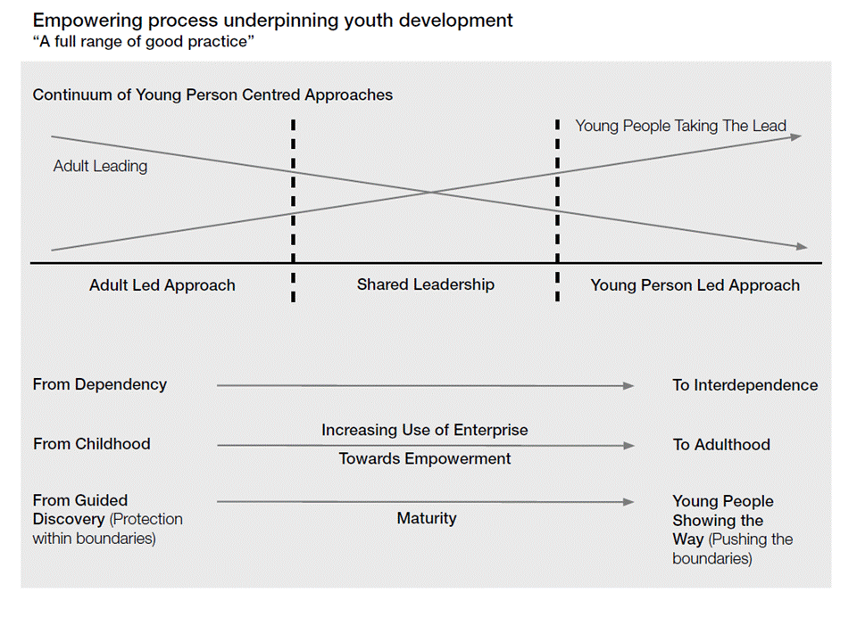

Youth Development
Practices

The youth development practices outlined below underpin the principles of Advance.

Respect:

- Young people participate in all levels of planning and decision-making

- Young people’s choices are encouraged and respected

- Everyone’s contribution is recognised

- Promotion is ethical, honest and non-patronising

- Formal and community recognition of learning outcomes is maximised

- Community involvement builds bridges between people and creates a strong foundation for respect.

Diversity:

- An inclusive attitude is displayed, difference is acknowledged and appreciated, and teaching is inclusive of different learning styles

- Community identity is respected.

Involvement:

- An experiential model of teaching and learning is used

- Communities are encouraged to value and engage with young people

- Partnerships are used to deliver services and programs

- Meaningful opportunities for young people to contribute to the community are provided

- Young people’s social networks are developed.

Strengths-based practice:

- The strengths and abilities of young people are the focus.

Sustainability:

- Communities are built by creating connections between people and places.

(Based on AUSYOUTH 2001, “Good practice in youth development” p. 7.)

Benefits of Advance

Many community organisations actively seek to involve young people as members, volunteers or participants in their programs. They recognise this is a way to ensure their organisation is more relevant to young people and to involve them in society to better their future outcomes

Young people bring an exciting range of skills and perspectives to community organisations. As well as creativity, vitality, energy and different views, they are also typically better able to adapt and more open to change. All these attributes can benefit organisations that are committed to initiating change and being inclusive of their communities.

Young people who are engaged in education and community life make a positive contribution to the overall wellbeing of the community. Their participation helps build relationships between schools and local community organisations, and their energy and enthusiasm is a valuable community resource. The community gains positive outcomes from community projects, as well as having young people demonstrate positive community involvement.

By participating in Advance, young people are recognised and celebrated by the broader community for their strengths and abilities while they develop a range of life skills and connections with their community.

The benefits of Advance will be realised when:

- Communities support young people’s participation

- Young people and their developmental needs are considered in local program design

- A positive, healthy and safe environment is provided

- There is a balance between challenge, guidance and freedom

- There are positive, clear, consistent and age appropriate guides for behaviour

- Conscious, consistent efforts are made to develop young people’s and community organisation members’ skills and knowledge.

The benefits for community organisations include:

- Raising the profile of the organisation with young people and the community

- Creating links with other community organisations

- Introducing volunteering to young people and establishing links for their ongoing involvement

- Accessing new networks and involving young people in short-term projects

- Receiving an injection of new ideas, enthusiasm and different perspectives

- Having the organisation’s education material linked with formal education pathways.

The benefits for young people include:

- Learning more about their community and how they can contribute

- Becoming more socially involved with their community

- Increasing their confidence, self-esteem and emotional wellbeing.

- Working in teams to achieve shared goals

- Developing leadership and communication skills
- Participating in decision-making about the program

- Developing project management and budgeting skills

- Developing a network of relationships with people from the broader community

The benefits for schools include:

- Developing closer links to their community

- Creating a positive profile for the school and young people in the community

- Offering students a broader range of interactive and challenging learning experiences and opportunities

- Providing staff with new experiences and skills development

- Assisting young people to make a positive contribution to the school and community.

2
Advance Components

Advance Program
Framework

The Advance program framework consists of three levels:

- Five key program components

- Program delivery timeframe options

- The local delivery strategy.

Schools have ultimate responsibility in ensuring the Advance components (outlined below) are met. These components, which are built on the best practice principles of youth participation, are:
- Learning Modules;
- Learning Module 1: Community
- Learning Module 2: Communication
- Learning Module 3: Project Management
- Recognised training

- Community project(s) or series of volunteering activities delivered in partnership with a community organisation

- Celebration and recognition of young people’s achievements

- Young people are involved in decision-making

- Advance reporting and evaluation.

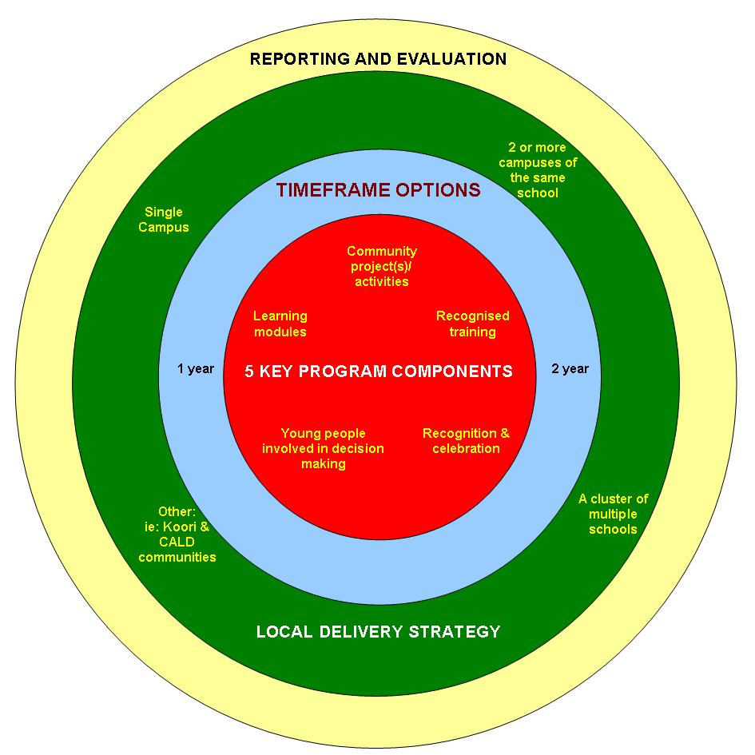

Learning Modules 1, 2 & 3

The youth development practices guiding Learning Modules 1, 2 and 3 are:
- The strengths of young people are the focus

- Young people’s opportunity to participate in planning and decision-making is maximised

- An experiential model of teaching and learning is used

- Young people’s choices are encouraged and respected.

The Learning Modules 1, 2 and 3 are available at: https://www.youthcentral.vic.gov.au/get-involved/advance/information-for-schools-and-teachers/resources-and-support-for-teachers-and-schools
Learning Module 1: Community

The focus of Learning Module 1 is to develop young people’s self-knowledge and increase their understanding of their community and volunteering opportunities. This module includes the following learning components:
- Knowing their own strengths and weaknesses
- Identifying their passions and interests
- Establishing of goals
- Understanding what community means
- Identifying people and places (including natural resources) in their community
- Identifying current and potential connections between young people and the community
- Being aware of the community organisations that service the local community
- Being aware of how young people can access these services
- Knowing what volunteers do
- Understanding the rights and responsibilities of volunteers
- Identifying what activities they already do as volunteers
- Identifying volunteer activities within the school and local communities.

Learning Module 2: Communication

The focus of Learning Module 2 is on strengthening young people’s communication skills and teamwork. This module includes the following learning components:
- Being able to give and receive feedback
- Recognising the importance of good teamwork
- Being aware of individual contribution and roles of others in a team
- Understanding the benefits of teamwork compared to working alone
- Understanding the types of feedback
- Identifying the desired outcome they want and the means to achieve it
- Identifying areas of agreement
- Understanding the negotiation process
- Defining the problem
- Brainstorming solutions
- Trialling solutions
- Reviewing the outcomes and discussing the result
- Identifying the audience and purpose of a report
- Identifying appropriate information to include in a report
- Identifying appropriate style of a report
- Understanding how to plan and produce a report.

Learning Module 3: Project Management

The focus of Learning Module 3 is on building young people’s project management skills. This relates specifically to the Advance community project(s) or series of volunteering activities that young people deliver in partnership with a community organisation. This module includes the following learning components:

- Researching possible community projects or volunteering activities
- Identifying resources available to possible community project(s) or volunteering activities
- Selecting a community project(s) or series of volunteering activities
- Deciding on the intended outcome and evaluation criteria
- Developing a project plan that includes;
- Tasks that need to be completed
- Who will complete each task
- When the task will begin and end
- Implementing the project plan
- Monitoring the project plan
- Conducting the evaluation of your community project(s) or volunteering activities
- Reflecting on learning gained from the community project(s) or volunteering activities
- Reporting to organisations and presenting a report to the identified audience
- Celebrating the completion of the community project(s) or volunteering activities.

Accountability
Schools must be able to demonstrate that young people have satisfactorily achieved the learning outcomes contained in Learning Modules 1, 2 and 3.

NB Achievement of the Advance learning outcomes is flexible for schools operating in special and special developmental school settings.
Recognised Training

Recognised training courses are those that:

- Have accreditation through the Australian National Training Authority, such as Certificate 1 in Volunteering or a Certificate 1 in First Aid;

or

- Are recognised by the community as developing knowledge and skills for participation in particular activities.

A recognised training course will usually:

- Take about 20 hours (if less than 20 hours, more than one form of recognised training can be completed to total around 20 hours)

- Result in the development of a new skill

- Have a certificate awarded at the end of the program

- Be delivered away from the school

- Be delivered and/or assessed by someone other than school staff.

If two or more of these don’t apply, the course is probably not suitable. If there is strong commitment to such a course from the young people, the Department of Families, Fairness & Housing should be contacted for help to clarify course suitability.

Examples of recognised training are The Duke of Edinburgh’s Award, a license to broadcast issued by a community radio station after young people have completed an induction course, building wildlife nesting boxes, food handling, and sporting referee or coaching qualifications.

It is acceptable for young people to complete units that are part of a larger course provided they can obtain credit for these unit/s if they decide to complete the course in the future.

Accountability
Schools must be able to demonstrate that young people have satisfactorily completed recognised training.

NB Achievement of the Advance learning outcomes is flexible for schools operating in special and special developmental school settings.
Community Project
Or Series of Volunteer Activities

A key component of Advance is the development of a partnership between young people, the school and a community organisation to complete one or more community projects or volunteering activities.

Community projects or volunteering activities can take a variety of forms including:

- Taking part in existing volunteering opportunities, such as Conservation Volunteers Victoria, a creek revegetation program, peer mediation or interacting with residents at a local nursing home

- Planning and implementing an information campaign

- Developing, implementing and evaluating a community event

- Producing a resource for the community.

Many schools are already engaged with community organisations and/or programs administered by government departments or agencies.

Some of these include:
- Australian Red Cross Victoria
- Bicycle Victoria
- Country Fire Authority (CFA)
- SCOPE
- Parks Victoria
- St John Ambulance
- Urban Seed
- Immigration Museum
- Australian Defence Force cadet programs
- World Vision.

In some cases, more than one community organisation may need to be involved to satisfactorily implement the project(s) or volunteering activities the young people have chosen.

Young people may also choose to work in partnership with multiple community organisations on a range of different volunteering activities.
Schools and community organisations will plan and document the project or series of volunteering activities and the roles and responsibilities of all involved. The School Community Partnership Notification Form (see example in Appendix) may be used to submit partnership information to the Department of Families, Fairness & Housing.

Accountability
Schools must be able to demonstrate that there has been engagement between young people and one or more community organisations to deliver a community project or series of volunteering activities.

NB Achievement of the Advance learning outcomes is flexible for schools operating in special and special developmental school settings.

The School Community Partnership Notification Form template can be downloaded from: https://www.youthcentral.vic.gov.au/get-involved/advance/information-for-community

An example of this template is provided in the Appendix.

Celebration and
Recognition of
Young People’s
Achievements

Celebrating and recognising personal and group achievements is an important and positive component of any project or partnership and encourages continued effort and commitment.

Everyone should make the effort to recognise and celebrate achievements along the way as well as at the end of the project or series of activities. This encourages continued effort, commitment and encourages people to have fun.

Recognition and celebration can range from informal acknowledgements that take place within the group, to formal public events incorporated throughout the program rather than only at the conclusion.

This involvement could take the form of:

- Regular volunteer recognition and celebration events

- The presentation of certificates of achievement - templates provided at:

https://www.youthcentral.vic.gov.au/get-involved/advance/information-for-schools-and-teachers/resources-and-support-for-teachers-and-schools

- Articles and photos in local papers providing publicity for the partnership and project or activities

- Public demonstrations or exhibitions

- A lunch or barbeque

- An activity the young people choose.

Accountability
Schools must demonstrate that the young people’s achievements and the participation of everyone involved have been appropriately recognised.

NB Achievement of the Advance learning outcomes is flexible for schools operating in special and special developmental school settings.

Young People Involved in Decision-Making

It is essential that young people have opportunities to participate in planning and decision-making at the local level. Opportunities for involvement include:

- Nominating and/or choosing the community organisation they engage with

- Deciding the type of project or activities that are undertaken

- Contributing to decisions about which recognised course is undertaken

- Negotiating project or activity plans with community organisations

- Deciding how the program is celebrated and promoted

- Participating in decisions about how the program funding is used.

It is expected that teachers and community partners will provide opportunities for young people to take a more central role in planning and decision-making as the program develops and participants’ skills and experience increase.

Accountability
Schools must be able to demonstrate how young people have participated in decision-making.

NB Achievement of the Advance learning outcomes is flexible for schools operating in special and special developmental school settings.

Reporting and
Evaluation

Evaluation provides information that allows effort to be recognised and achievement to be properly acknowledged.

A range of evaluation methodologies are built into the Advance Learning Modules 1, 2 and 3, from personal assessment of goal attainment to project evaluation against planned outcomes.

Schools must also provide reports to the Department of Families, Fairness & Housing on the program (See section 3: ADMINISTRATION AND REPORTING).

The reporting will include:

- Quantitative information including enrolment numbers and achievement of accountabilities

- Budget acquittal

- Qualitative information including satisfaction measures and anecdotal information captured in a program description.

The Advance End of Year Reporting template will be sent to Advance Coordinators and generic school addresses. It is to be submitted both as an unsigned Word document and signed PDF.

Schools delivering Advance are responsible for formal reporting to the Department of Families, Fairness & Housing.

Community organisations, as partners, are encouraged to be aware of the required reporting process and to contribute as appropriate.

Accountability
Schools must lodge monitoring and evaluation information, including detailed financial reporting on the expenditure of Department of Families, Fairness & Housing funding.

NB Achievement of the Advance learning outcomes is flexible for schools operating in special and special developmental school settings.

Flexibility - Different
Program Delivery
Models

Advance’s flexible framework has been developed to allow for maximum local decision-making by schools and young people who are participating in the program.

The most common model is a partnership between a school and a community organisation to deliver a single community project or volunteer activities for the entire class.

A school may also choose to work in partnership with multiple community organisations to best meet the needs of the young people involved in Advance. The partnerships can take a variety of forms and run for range of time spans.

Some schools already have an established relationship with a community organisation and a program that can easily be adapted to Advance.

School campuses may choose to work together to deliver Advance and/or share resources.

Some schools may choose to work in a cluster model and participate in shared activities, work closely or even deliver Advance in different ways, but still share resources.

The Level of Community Organisation Involvement

A key focus of Advance is young people working in partnership with community organisations. A community organisation’s involvement in an Advance partnership provides a learning environment and an opportunity to support young people.

Advance’s flexibility enables each community organisation to determine its own level of involvement. However, the young people, the school coordinator and the community organisation should negotiate the level of involvement.

There is opportunity for community organisations to partner one or more schools and to be involved in all, a few, or even one component of the program.

Community organisations may partner with young people and schools in a variety of ways such as:

- Informing young people about their organisation by providing direction to a website, brochures and detail of the organisation’s vision, aims and objectives

- Interacting with young people in activities such as hosting a visit from the school or visits by staff or volunteers to the school

- Actively supporting young people’s community project or series of volunteering activities

- Providing recognised or accredited training to young people

- Providing professional development for teachers

- Recognising and celebrating the participation and contribution of young people in the community.
3

Administration and Reporting

Monitoring and Reporting Timelines

Date: | Status: | Documentation Requirement:
February | Required | All participating schools will be required to submit a completed:  - Funding and Service Agreement  - Confirmation of Student Numbers Form  - Confirmation of School Banking Details Form
From March | Upon receipt of required documentation | - Department of Families, Fairness & Housing processes payment of Advance grant to schools
End of each Term | If Applicable | - Schools to provide notification of any changes to Coordinator details
By end of Term 2 | Voluntary | - School Community Partnership Notification Form submitted by schools
First week in December | Required | - Advance End of Year Reporting consisting of:  - Section 1 – School contact details  - Section 2 – Local delivery strategies  - Section 3 – Program description  - Section 4 – Program reporting  - Section 5 – Budget acquittal  - Section 6 – Declaration

Duty of Care and
Legal Issues

The material provided here has been prepared to provide general information only. It is not intended to be relied upon or be a substitute for legal or other professional advice.

The Department of Education and Training School Policy and Advisory Guide outlines the responsibility, authority and accountability for the management, administration and operation of schools. Advance school coordinators are required to adhere to this reference guide.

School responsibilities

Schools are ultimately responsible for the program and are required to:
- Provide teachers to coordinate and supervise the program
- Provide information to community organisations about their liabilities
- Ensure effective communication occurs with the community organisation.

Schools are also expected to:
- Monitor progress of both young people and the program
- Facilitate the program processes rather than lead
- Ensure appropriate resources are available, and monitor budget expenditure
- Play a role in recognising and celebrating young people’s contribution to community
- Compile reporting requirements for the Department of Families, Fairness & Housing
- Ensure parents have enough information about Advance so they understand what they are agreeing to when they sign permission forms
- Ensure particular events, such as camps or excursions, are covered by the school’s usual permission forms
- Include a release for permission to use photos of the young people if the school does not have a general release as part of enrolment.

Areas of interest for Advance may be found in, but are not limited to, the following sections:

Topic | Section | Link
Curriculum | Programs; Safely Delivering Curriculum; Student Assessment and Reporting  Suitable Teaching and Learning Resources | www.education.vic.gov.au/school/principals/spag/curriculum/Pages/curriculum.aspx
Facilities and infrastructure | Property and Asset Management | www.education.vic.gov.au/school/principals/spag/infrastructure/Pages/buildinfra.aspx
Finance | Budget and Accounting Requirements; Financial Records; Insurance | www.education.vic.gov.au/school/principals/spag/finance/Pages/finance.aspx
Governance | Risk Management; Safety Management; Safety Response Using Social Media | www.education.vic.gov.au/school/principals/spag/governance/Pages/governance.aspx
Human Resources | Employment Conditions;  Professional Development; Safety, Health & Wellbeing | www.education.vic.gov.au/school/principals/spag/hr/Pages/hr.aspx
Management | Emergency and Critical Incident  Operations; Relationship with the Media | www.education.vic.gov.au/school/principals/spag/management/Pages/management.aspx
School community | Partnerships and Sponsorships;  Volunteer Checks | www.education.vic.gov.au/school/principals/spag/community/Pages/community.aspx
Student health | Care and Support; First Aid | www.education.vic.gov.au/school/principals/spag/health/Pages/studenthealth.aspx
Student participation | Student Engagement; Attendance | www.education.vic.gov.au/school/principals/spag/participation/Pages/participation.aspx
Student safety | Excursions and Activities; Protection and Support; Supervision and Access; Transporting Students. | www.education.vic.gov.au/school/principals/spag/safety/Pages/safety.aspx

Community organisation responsibilities

In a partnership with a school, a community organisation will:

- Ensure when young people choose to do an activity with a community organisation in their own time, not as part of the school program, that the community organisation’s policies and procedures apply

- Ensure all adult employees, board members and volunteers of organisations (aged 17 years and over) who come into direct and unsupervised contact with young people participating in Advance be subject to criminal record screening

- Ensure organisations entering an Advance partnership with schools have a sound knowledge of relevant legislation and policies (occupational health and safety, duty of care, child protection), and policies relevant to the school and organisation

- Champion young people’s opportunities to participate in planning and decision-making

- Where applicable and possible, provide adequate facilities and equipment

- Ensure organisation representatives have appropriate skills to deliver the community partnership component of Advance.

Insurance

It is important to check the extent of the community organisation’s insurance cover to ensure that any activities undertaken as a part of Advance by young people and volunteers are appropriately insured.

Schools and community organisations may wish to seek legal advice regarding risk, insurance limits and liabilities with respect to:

- Public liability insurance of a minimum of $10,000,000

- Personal accident insurance (sometimes known as Volunteer Insurance)

- Professional indemnity risk

- Personal accident

- Property damage.

If young people choose to take part in an activity with a community organisation in their own time, and not as part of the school program, the community organisation’s policies and procedures apply.

Risk Management

Unexpected things happen.

Unfortunately, in some situations, this could mean a serious impact on physical welfare, or have serious financial implications for community organisations, the staff and associated volunteers.

To minimise the risk and to protect the volunteers working with a community organisation, it is important to work through a process of risk management, identifying potential risks and developing strategies to prevent or reduce them.

No Weapons Policy

The outcomes of Advance are achievable without the need for weapons for training.

Weapons, of any kind, are not a part of Advance.

Funding

Victorian Government secondary school campuses are eligible to receive up to $9,800 (excluding GST). This funding amount is available for a minimum of 21 students. To cater for schools with low student enrolment, schools that enrol less than 21 students will be funded proportionately.

Funding of $875 (excluding GST), specifically for teacher professional development, is provided to each school campus delivering Advance regardless of funding levels.

Schools are required to acquit the funding granted against expenditure and demonstrate how the use of the funds has met program accountabilities. The allocation includes funds to purchase or hire:

- Services from community organisations

- Equipment directly related to the community project or series of activities

- Venues and cover associated costs

- Training materials

- Access to recognised training courses

- Transport

- Off-site activities

- Photocopying, printing and telephone costs directly related to the delivery of Advance

- Uniforms required for OH&S purposes.

Funding MUST NOT be used to employ a teacher to coordinate the program or to purchase assets for the school.

Schools may fundraise to provide additional resources for Advance, and such fundraising could be part of the community project(s) or volunteering activities.

Schools may also charge young people a reasonable levy provided no young person is excluded by inability to meet the levy charge.

Schools must complete and submit the End of Year Report to meet the conditions of the Funding Agreement, and to be eligible for Advance funding in the following year.

The Funding Agreement is available from the Department of Families, Fairness & Housing. It must be completed and a copy signed by the principal submitted to the Department of Families, Fairness & Housing.

Any unexpended funds may be deducted from future payments and must be returned to the Department of Families, Fairness & Housing if the program is no longer to be delivered at the school.

4
Community Partnerships

The opportunity for young people to extend their networks, build partnerships and become more involved with with known and trusted adults in community organisations is central to Advance. These partnerships aim to assist young people to become confident, skilled, competent and active members of their community.

Entering a partnership with a school is an exciting and rewarding opportunity for a community organisation and its members. Like any partnership, it is important to establish a solid base and a strong understanding of both parties’ expectations and requirements for beneficial partnership.

Advance’s flexibility enables schools to work exclusively with one community organisation or in partnership with a number of organisations who may be involved in all, a few, or just one component of Advance.

To support schools when entering a partnership, a listing of useful resources has been provided in Section 7: OTHER INFORMATION. In particular Volunteering Australia, the national peak body working to support and promote volunteering in Australia, is a great resource. A wide range of information for both volunteers and community organisations is available on its website at:

www.volunteeringaustralia.org.

GoVolunteer is an initiative of Volunteering Australia and is a volunteer recruitment website. It is a not-for-profit site that provides free internet advertising for not-for-profit community organisations looking for volunteers. GoVolunteer provides access to volunteer opportunities and helps match volunteers with suitable community organisations. The website is:

www.govolunteer.com.au

Another notable resource is Our Community: Building Stronger Communities through Stronger Organisations.

The website: www.ourcommunity.com.au
provides a gateway for practical resources, support and linkages between community networks, the public, business and government. In addition to the general information provided on the website, there is a range of help sheets available that target community organisation/business partnerships.

Community organisations are invited to provide their contact details and a short description of their organisation and ways they are interested in working in partnership with young people for listing on the Department of Families, Fairness & Housing website.

Young people and schools are encouraged to visit the website when they begin to investigate possible community projects, volunteer activities and organisations to work in partnership with.

The Victorian Government’s website: www.volunteer.vic.gov.au also provides information for volunteers and volunteer organisations. The Best Practice Toolkit available from this site is an information resource for people involved in running a community organisation that involves, supports or manages volunteers.

It aims to help people share information, tips, guides, case studies, templates, and other tools they use to run volunteer programs and meet the challenges of operating successful volunteer-involving organisations.
Successful
Partnerships

What helps to make a successful partnership?
- Commitment to the goals of Advance
- A genuine interest in young people and communities
- A willingness to commit to a partnership with young people and schools
- Training that is structured and interesting (if delivering this component)
- A willingness to reflect on practice, with a view to improving outcomes for all involved.

Experience has shown that the most beneficial partnerships for both school and community organisation partnerships exists when:

- The people involved work to develop a common understanding about their joint objectives, authority, management and responsibility
- There is a mutual investment of resources, shared liability and risk-taking, and mutual accountability for the outcomes for young people
- There is mutual recognition of the contributions of each party
- Time is invested in maintaining the relationships between the people involved.

(Based on AUSYOUTH 2003, “School and community partnerships for youth development”, p.5.)

Advance’s flexibility enables each community organisation to be involved to a level that is suitable for them. There is opportunity to partner one or more schools and to be involved in all, a few or even one component of the program.

Community organisations can be involved in:
- Presenting elements of the Learning Modules1, 2 and 3
- Providing the recognised training
- Supporting the community project(s) or series of volunteering activities
- Actively recognising and celebrating young people’s participation and contribution.

An established focus

If the year level where Advance is delivered has an established focus, such as ‘environment’, a school may choose to build Advance into that focus. When this choice is made, the school needs to identify the aspects of the program where young people will make choices.

An established relationship

A school may have an established relationship with a community organisation that could be further developed through Advance. Discussing possibilities with community contacts is a good beginning.

A new relationship

A new relationship with a community organisation may be made through school staff or other contacts. The school principal should be kept informed about any new relationship with a community organisation.

To locate a suitable community organisation to be your partner you can also:
- Use existing networks
- Approach the Volunteer Resource Centre (VRC) in your area for advice
- Access the Department of Families, Fairness & Housing and Advance Online Forum websites
- Search the internet, including the Volunteering Victorian website at:
www.govolunteer.com.au

In considering a partnership, schools and community organisations will need to share information. This could include:

- Annual reports
- Organisational structures
- History of involvement in similar partnerships
- Profile of people who will be involved
- Newsletters
- Their understanding of Advance
- Resources they would bring to the partnership.

Factors for schools to consider:

- Is the philosophy of the organisation compatible with Advance and the ethos of the school?

- Does the organisation have experience of including young people in its programs or structures?

- Does the organisation have the resources to contribute to the partnership? These could include:
- Staff and volunteer time for preparation
- Program delivery
- Evaluation
- Reflection
- Meetings
- Resources for travel
- Materials
- Equipment
- Communications
- Events
- Record-keeping materials
- Space
- Will the planned involvement be sustainable?

Factors for community organisations to consider:

- Is the school community aware of the community organisation’s work?

- Is the school willing to promote the organisation’s work?

- Is the school able to meet the organisation’s particular needs including being flexible about the:
- Availability of volunteers?
- Time of year that the organisation can offer involvement?

What contributions can the school make to the community organisation?

These could include:

- Purchasing services such as recognised training and/or investment in a community project/series of volunteering activities

- Resources such as paper and photocopying

- Use of buildings or equipment for other organisational activities

- Support to develop appropriate materials for the particular school population.

(More information about partnerships between schools and community organisations is available from AUSYOUTH 2003, “Schools and community partnerships for youth development.”)

Managing Conflict

Despite the best of intentions, there may be times when conflict occurs in a school-community organisation partnership.

Regardless of the level or object of conflict, if the issue is left unresolved it could impact on the partnership’s health.

Resolving differences amicably and working toward win-win solutions will result in better outcomes for all involved.

The following are some basic tips for managing and resolving conflict:

- Think positively when approaching an issue of point of conflict

- Deal with conflict as soon as practical because waiting could allow the conflict to increase

- Remain impartial and allow each party to express their views. Avoid inflaming the situation

- Listen carefully to gain a clear understanding of the issue/s and different viewpoints

- Identify the common positive aspects and the points of disagreement

- Look for pathways forward that positively deal with the points of disagreement

- Open discussion around differences; focus on problems, not personalities

- When an agreement is reached, articulate it clearly and record it to ensure there is a shared understanding and commitment to the solution.

School Community
Partnership
Agreement

In collaboration, young people, schools and community organisations will need to develop a School Community Partnership Agreement.

A template for the School Community Partnership Notification Form is available at Youth Central.

Working through this template will assist you to ensure all parties involved share a clear understanding of the expectations and activities planned through a partnership.

The school may send a copy of this form to the Department of Families, Fairness and Housing.

This template is at: https://www.youthcentral.vic.gov.au/get-involved/advance/information-for-community

5

Volunteering

The key message of Advance is that young people contribute to the community in partnership with a community organisation. A youth development model, which is underpinned by young people led activities that recognise and celebrate the value of young people’s participation, drives this community involvement.

One way of introducing and/or encouraging young people to learn and contribute further to their community is through volunteering; hence, a key goal of Advance is promoting and valuing young people volunteering.

In Advance, young people will be working as volunteers and working with volunteers. Before beginning any volunteer activities, young people should be aware of:
- The responsibilities of the organisation toward them
- The responsibilities of workers toward them
- Their rights and responsibilities as volunteers.

There are two types of volunteering: informal and formal. Informal volunteering is work that community members, neighbours and friends do for each other that is spontaneous, flexible and doesn’t depend on an organisation to make it happen.

The Advance work will focus on formal volunteering. Formal volunteering is an activity that takes place in not-for-profit organisations or projects and is undertaken:

- To be of benefit to the community and the volunteer
- By the volunteer of their own free will and without coercion
- For no financial payment
- In designated volunteer positions only.
Volunteering is directly linked to the Advance Learning Module 1 of the curriculum materials where the different aspects of volunteering are covered.

In Advance, opportunities for community volunteering have been grouped into seven themes conforming to the information on the GoVolunteer website at:
www.govolunteer.com.au

Victoria's Volunteering Portal

Victoria's Volunteering Portal is an online community and information resource for Victorian volunteers and volunteering organisations. It aims to inform, support and inspire everyone involved in volunteering through:

- Detailed information for prospective and current volunteers about how, where and why to volunteer
- A central source of best practice information, tools and resources for volunteer managers, coordinators and others involved in running volunteer organisations
- Opportunities to share stories, recognise achievements, give feedback and learn through others in the volunteering community

Victoria’s Volunteer Portal can be found at: www.volunteer.vic.gov.au

Area | Possible volunteering opportunity
Animal welfare | Volunteering at an animal shelter  Raising awareness about animal rights
Arts/culture/heritage | Developing a music event  Working with the local council on public art
Community services/health/welfare | Volunteering with Meals on Wheels  Raising awareness of a health or safety issue
Conservation/environment | Volunteering with an environmental group  Implementing a recycling program
Emergency services/safety | Volunteering with SES, CFA or St John Ambulance  Raising awareness about safety in the community
Human rights/social justice | Raising awareness about issues such as youth homelessness  Participating in a campaign with Amnesty International
Sport/recreation | Coaching a sports team or group  Providing opportunities for recreation for a particular group

Volunteering Australia

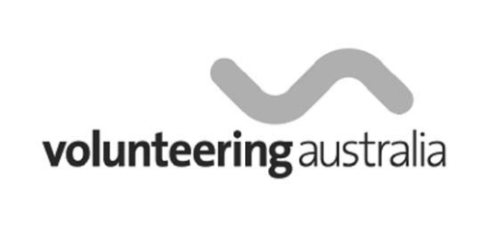
Volunteering Australia is the national peak body for volunteers in Australia working to further volunteering in the Australian community.
Together with their affiliated state bodies
(Volunteering Victoria in Victoria), it supports volunteers throughout Australia and provides advice to governments and organisations that include volunteers in their programs.

Its mission is to represent the diverse views and needs of the volunteer sector while promoting the activity of volunteering as one of enduring social, cultural and economic value. Volunteering
Australia exists to raise the profile of volunteering and to ensure the contribution volunteering makes to society is counted and recognised.

Volunteering Australia provides a range of services including volunteer referral, training, resources and information to volunteer organisations and volunteers.

The following information has been developed by Volunteering Australia and is available from the Go Volunteer website at:
www.govolunteer.com.au

The information is provided to support schools to work successfully with young people and community organisations through Advance.

There is often a misconception that young people are not interested or involved in volunteering. In fact, young people (16 to 24 years old) are a growing volunteer base.

According to the Australian Bureau of Statistics (2000), the biggest growth area in volunteering was young people. There was an increase in participating 18 – 24 year olds from 16.6% to 26.8% between 1995 and 2000.

A few hints for organisations looking to attract young volunteers are outlined over the page.

What young people can offer:
- Energy and enthusiasm
- A fresh perspective and new ideas on how your organisation can do things
- Skills and abilities, in particular ‘new’ skills
- especially in new Information and Communication Technology
- A young person’s point of view
- A way of sustaining your organisation into the future by bringing in a younger generation of volunteers
- Opportunity to involve existing staff/volunteers in training and mentoring new volunteers.

Why young people get involved:

- To become involved in their community
- To gain satisfaction from doing something to make a difference to the world To acquire skills;
- Job skills
- Communication skills
- Personal skills
- Professional development skills
- To gain experience: especially to be able to add to their CV or to gain a reference
- To have fun
- To meet new people
- To experience new challenges.

Attracting young people to your organisation:
- Visit: www.govolunteer.com.au a free not-for profit volunteer-matching website. Some 14,000 people under the age of 24 visit GoVolunteer each month

- Market your position with young people in mind. Is the image you are portraying of your organisation interesting to young people?
- List ‘what’s in it for them’. It may be meeting new people, a reference, something to add to their CV, training, personal satisfaction, helping a cause or learning new skills
- If you have policies about extra benefits in your organisation, mention them in your advertisement (such as reimbursements for travel expenses, monthly get-togethers for staff and volunteers, lunchtime walks in the park)
- Think creatively about your volunteer roles.
- Divide tasks into ‘projects’ and think about which tasks could be done by a team of young volunteers
- Be flexible about the timing of involvement.
- Some young people may need to regularly change the day that they volunteer to fit with their other commitments. Many young people juggle work and study, and need to adjust their volunteering as their commitments change
- Look for shorter commitment such as more project-based tasks
- Make it easy for young people to get involved by minimising the screening/induction required
- Reply to enquiries and correspondence as soon as possible. Remember, it is the age of instant communication! Invite the volunteer in so you can meet them and tell them more about the position. If you are happy they can perform the role and they are still interested in helping you, set a time for them to start
- Make your job description sound interesting. For example, do not begin a gardening position description with ‘Weeding’, begin it with ‘Enjoy the outdoors!’
- Check that your Volunteer Insurance policy covers your younger volunteers
- Involve young people in evaluating the program to improve and develop it.

Examples of youth-friendly projects and youth-friendly language

The following examples are case studies provided by schools delivering Advance:

- Planting trees - they can see instant results
- Painting fish on drains to remind people what we put down the drain goes into our rivers
- Involving computer tutors teaching older people about computers and the internet
- Volunteering at a local ‘op shop’ and then opening a second-hand uniform shop at school
- Designing promotional brochures for an animal shelter
- Lifesaving on the beaches through local surf clubs and doing real patrols
- Assessing applications for grants for youth programs through the Grant Makers program
- Running a music program for kindergarten kids
- Planning and running activities at the Panton Hill Festival
- Recording community service announcements that were played on air by the PVFM 88.6 radio station.

Retaining young volunteers:

- Show appreciation and recognise your volunteers - value their contribution
- Give, ask for and listen to feedback
- Give volunteers ownership/responsibility of a particular project. Give them leadership and decision-making opportunities
- Provide on-the-job training

- Provide clear job descriptions
- Enable your volunteers to have input into the planning phase
- Allow volunteers to develop their roles in areas that are of particular interest to them
- Include them as part of your team. Ensure they meet everyone and feel welcome
- Introduce volunteers to each other – foster relationships
- People make mistakes and so can volunteers.
- Don’t undercut your volunteer’s confidence.
- Look at mistakes as learning exercises
- Be flexible. Ensure your volunteers know that you are prepared to adjust their volunteer work to suit their schedules.

What discourages young people:

- Poor organisation of tasks, orientation in the organisation or supervision of the volunteer
- Unsatisfying jobs
- Unclear job tasks
- Being talked down to
- Lack of feedback
- Lack of recognition.

Note: This information is copyright to Volunteering Australia under the Copyright Act 1968 and has been reproduced here with the kind permission of Volunteering Australia. It may be reproduced in whole or in part for study or training purposes subject to the inclusion of an acknowledgement of the source and no commercial usage or sale. Reproduction for other purposes requires the written permission of Volunteering Australia Inc.

6
Promotion

Promoting Advance

Promotion should focus on presenting the strengths and achievements of Advance to a target audience. Activities that are planned to promote Advance should create an understanding of the program and a positive attitude towards the program. Young people should be included in making choices about preparing and presenting materials to promote Advance.

There are a number of audiences for promotion and providing information about Advance including:

- The School Principal

- The School Council

- The School Staff

- Other young people

- Parents

- Community organisations members including management boards, members and volunteers

- The local community.

The school community

The school principal is ultimately responsible for the delivery of Advance within a school and should be kept informed of how the program is going, particularly of any highlights!

School council members are important stakeholders who need to be kept up to date with program developments and plans. They should be informed about progress toward meeting accountabilities, the achievements of the participating young people and budget monitoring.

The nature of Advance means there are sometimes disruptions to the school routine that affect other staff members. Keeping the whole school informed about the program, the young people’s achievements and planned activities helps to ease any tensions that might occur.

Parents

Reports to parents could be included in the normal reporting processes of the school. The Advance Support Resources for Government Schools includes information about formal reporting.

Reporting to parents of participating young people is an excellent opportunity to promote Advance to the school community. Consider displaying photos or videos of activities or posting information on the school’s website.

Community organisations

Community organisations will be interested in the progress of the young people involved.

Providing opportunities for young people to give both formal and informal feedback about their progress and experiences to the participating community organisation/s is a useful way to involve them in the delivery of the program, and to motivate community organisations to continue to be involved.

Local community

Advance activities make good news stories about young people for the local media. Local community newspapers and radio stations can help inform the community about the program.

Young people can be fully involved in these activities. A small group could be responsible for planning and delivering all promotional activities. Young people can build a relationship with media outlets and prepare and send out media releases.

Media Releases

Media releases can be used to distribute messages about Advance, your school and the community organisation to the general public. You can use a media release to inform the media of a planned event and invite them to send a photographer if there is any photo opportunity.

You can also use a media release to inform the media of particular achievements that have a positive impact for the students, school, community organisations and the community. This is a component of Advance where young people can take the lead.

It is a good idea to involve partnering community organisations in all media promotion. Use a range of promotion activities such as:

- A presentation

- Written material

- Video footage

- Photographs

- Newspaper articles

- Local radio

- Displays/exhibitions

- Newsletters

- Flyers and posters.

Please note: any materials prepared about Advance must adhere to the style guide for the use of the Advance name. The style guide is available through the Department of Families, Fairness & Housing.

The Department of Families, Fairness & Housing suggests that media releases could be utilised to:

- Announce the school and community organisation partnership

- Outline the community project or series of volunteering activities

- Recognise and celebrate young people’s achievements.

Advance Program
Logo and Branding
Guidelines

The Advance image is available for use on material produced by schools and community organisations promoting Advance. These guidelines are designed to ensure all Advance branding is clear and consistent, and obviously related to Advance. The Advance image is a logo and must not be rewritten in any other font.

You should use these logos if you are designing a presentation, exhibition, flyer, promotion materials, information sheets or a news item. If you are also acknowledging other sponsors/organisations, the Advance logo must be at least equal in size to any other logo used.

Use Advance colours or black on white.



Is the item you are designing for a student/younger audience?

It is acceptable to use only the Advance image when designing promotional items such as
t-shirts or flyers for students.

What not to do with the Advance image

Do not make the image unclear by writing over the image:
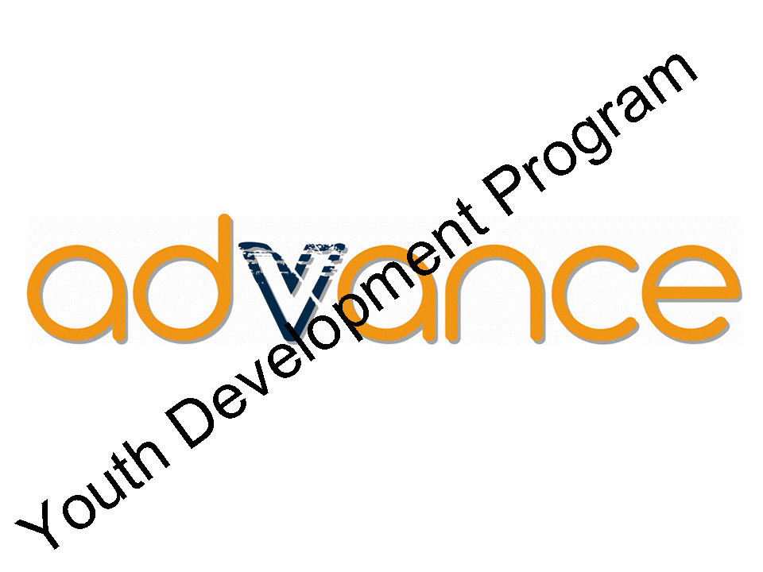

Or reversing or rotating the image:


You can request the images/logos by emailing:
advance@dffh.vic.gov.au

Acknowledgement of Victorian Government Funding

The funding for Advance is provided by the Victorian Government. It is important to acknowledge this contribution. Any publications and publicity related to Advance, including any print and electronic documents, such as brochures, websites, and reports, should include a written acknowledgement of this support and the Victorian Government logo. Press releases should also include a written acknowledgement.

Written acknowledgement
The written acknowledgement statement to be included in published or printed materials associated with Advance should include one of the statements below:

“The Advance program was supported by the Victorian Government.”

“The Advance program is supported by the Victorian Government.”

Victorian Government Logo
The State Government logo must be used in acknowledging Victorian Government funding as shown below. This should be included on any published materials either in the specified colour or in black and white. The Victorian Government Branding Policy must be followed when using a State Government logo.

Under no circumstances may this logo be altered without permission.



You can request the logos by emailing:
advance@dffh.vic.gov.au

Speeches and presentations
Any speeches and presentations should include a verbal acknowledgement of Victorian Government support for the Advance program. Where appropriate the relevant Minister should be acknowledged together with relevant references to the Advance program.

Further information
The department is in the process of writing detailed funding acknowledgement guidelines for funded organisations. The handbook will be updated to include a link to this resource in the near future. In the meantime, if you have any questions in relation to the funding acknowledgement please email:
advance@dffh.vic.gov.au

Useful Resources

The Advance Resources for Government Schools has been developed as a support tool to assist in the delivery of Advance. Schools wanting to research areas of interest more thoroughly will find a range of information sources that contain comprehensive information in this section.

Community organisation support

Our Community: Building Stronger Communities through Stronger Organisations is a comprehensive, dynamic resource for community organisations. The online Our community centres of excellence provides a one-stop gateway for practical resources, support and linkages between community networks, the public, business and government. Go to:

www.ourcommunity.com.au

In addition to the general information provided on the website, there is a range of help sheets available that target community organisation and/or business partnerships.

Forming partnerships

For schools and community organisations that want to understand the process of forming partnerships more thoroughly, the Northern Metropolitan Partnership is an advisory group established by the Victorian Government in 2017. The Partnership is a way for local communities to engage directly with state and local governments and advise the Victorian Government of the top priorities for jobs, services and infrastructure across the region. This advice becomes part of government’s key decision-making processes. For more information, visit:

https://engage.vic.gov.au/northern-metropolitan-partnership

Volunteering Best Practice Toolkit

The Best Practice Toolkit is an information resource for people involved in running a
community organisation that involves, supports or manages volunteers.

It aims to help people share information, tips, guides, case studies, templates, and other tools they use to run volunteer programs and meet the challenges of operating successful volunteer-involving organisations. It is available at: www.volunteer.vic.gov.au

Infoxchange

Infoxchange’s interactive website includes online community news and the Infoxchange Service Seeker that enable users to search by postcode for community service agencies and support details:
www.infoxchange.net.au

A partnership analysis tool

For community organisations and schools that would like to access the health of partnerships, VicHealth has developed ‘The partnership analysis tool’. Although this is targeted at partners in health promotion, it is a very useful tool for any organisation to utilise. It is available on the VicHealth website:
www.vichealth.vic.gov.au

Choose with care - a handbook to build safer organisations for children

End Child Prostitution, Child Pornography and Trafficking of Children for Sexual Purposes (ECPAT) Australia has developed a practical, user-friendly handbook designed to provide a range of child abuse prevention strategies. Choose with care aims to assist organisations to take decisive, informed and manageable steps toward establishing a child-safe environment in a 12-step approach. ECPAT also offers a training program to complement its handbook. For more information, contact ECPAT on
1800 991 099 or visit ECPAT website at: www.ecpat.org

Victorian Local Government
Association (VLGA)

The VLGA is a membership organisation that exists to promote good governance and sustainability by supporting local governments and communities through programs of advocacy, training, information provision and support. Where possible, the VLGA will work in partnership with governments, other peak bodies, non-government organisations, private enterprise, communities and individuals:

www.vlga.org.au

7
Other Information

Checklist for Getting
Started with Advance

Stage 1: Before you get started

Check to ensure your school is not already delivering Advance

Check Advance information on the Youth Central website to view the Advance Handbook for Government Schools. This resource will assist you to gain an understanding of the program

Have a clear understanding of the principles of youth development and youth participation.

Investigate the links your school already has with local community agencies

Consider how Advance may be delivered in your school, including:
- Appropriate timeframe of delivery
- Ability to timetable Advance during school hours for a minimum of two classes per week
- Ability of students to choose to participate in the program and spend time in the broader community
- Linkages within the curriculum
Consider school resources available for advance delivery, including:
- Staff with appropriate skills, experience and motivation
- Structures to support teacher professional development
- Support from a staff member in the principal class
- Support from the school council
- Clear documentation of school policy regarding working with community organisations and volunteers
- Established school community organisation partnerships or willingness to explore and develop linkages with community organisations

Meet with the principal class person who will be supporting your school program delivery to discuss support

Inform school council of plans to deliver
Advance

Consider the timetabling of Advance in the school curriculum

Visit the Advance web pages on the Department of Families, Fairness & Housing website and the Advance Online Forum for examples of Advance projects undertaken by young people at other schools.

Stage 2: Starting

Express your interest by contacting the Department of Families, Fairness & Housing at: advance@dffh.vic.gov.au

Check Advance information on the Youth Central website at:
www.youthcentral.vic.gov.au/get-involved/advance-0

Meet with the member of the principal class who will be supporting Advance and discuss support

Inform the school council about Advance

Submit the Advance Application Form to the department

Complete all necessary documentation to secure Advance funding

Consult the Victorian School Policy and Advisory Guide about all relevant guidelines at:
https://www.education.vic.gov.au/school/principals/spag/pages/spag.aspx

Prepare information and permission forms for parents

Alert the person coordinating reports about Advance

Arrange a separate funds charge code and photocopy number for Advance

Prepare application forms for young people

Complete a resources audit (an example resources audit is at the Appendix)

Prepare and present information to other staff

Book excursion/s and offsite activities and enter these in the school diary

Prepare permission forms for excursion/s and offsite activities

Stage 3: Learning modules

Download the Learning Modules 1, 2 and 3 from the Youth Central website at: https://www.youthcentral.vic.gov.au/get-involved/advance/information-for-schools-and-teachers-1

Identify people from the community to help deliver Advance (optional)

Set up record-keeping to support reporting on this accountability

Stage 4: Recognised training

Confirm with young people which training course/s they will do

Identify possible providers of recognised training

Confirm the logistics for young people to access and undertake the training

Enrol young people if necessary

Complete necessary checks for those delivering the training

Confirm how young people will be assessed for Advance and whether this needs any support

Confirm any information that will be needed for the young people to receive documentation about their course achievements

Sort out record-keeping for reporting this accountability

Stage 5: Community project or series of volunteering activities

Confirm the community project/ volunteering activities with the young people

Write a draft project plan (in Advance
Learning Module 3)

Identify possible partner community organisation/s

Make contact and negotiate how the organisation/s will be involved

Prepare an information pack for community organisation/s

Prepare the School Community Partnership Notification Form.
You may elect to send a copy to the department

Provide information to parents about activities the young people will do

Complete necessary checks for those who will be in contact with young people

Confirm how the young people’s experiences and achievements for this accountability will be recorded and promoted
Stage 6: Recognition and celebration

Identify who should be recognised in addition to the young people

Complete planning including who, what, when, where and how

Confirm record-keeping for reporting on this accountability

Stage 7: Evaluation and reporting

Organise to keep records of activities to report on accountabilities

Submit the Advance end-of-year report to the department at:
advance@dffh.vic.gov.au.

Roles

The Advance coordinator and teacher will be:

- Acting as a project manager
- Monitoring progress
- Ensuring resources are available and appropriate
- Monitoring the budget
- Monitoring the young people’s progress
- Recognising and celebrating young people’s contribution to the community
- Reporting to the relevant bodies
- Acting as a coach to the young people
- Acting as a community liaison manager who engages other people in the program including staff, community coordinator and the broader community

This is what teachers do in every subject, every day!

Planning for Program
Sustainability

The ongoing viability of Advance in each school depends on:

- Adequate planning and preparation
- Adherence to the principles of good practice in youth development
- An adequate resource base
- A succession plan
- Evaluation, monitoring and reporting
- A strong support base in the school and community
- Maintenance of quality and innovation within the program.
The benefits to teachers coordinating Advance include:
- Increasing their knowledge of the community sector
- Gaining knowledge of project management for their curriculum vitae
- Broadening personal and professional network
- Refreshing their teaching methods within a youth development framework
- Increasing their opportunities for further professional development.

Support group

Having a number of other staff with a working knowledge of Advance means that if the coordinator is absent for any reason, the program can continue.

A group of staff with excellent knowledge about the program can be formed through official channels or through the informal support networks that already exist within a school.

It is expected that a principal class leader will be allocated with the task of supporting the program and the coordinator. This can be done by forming and maintaining a group to support the coordinator.

If this is not done by the principal class leader, the coordinator can choose a team of people who are willing to support the program. This can be done by keeping them up to date with the material covered in class, plans and developments by making extra copies of planned work and other materials.
School staff

It is important that the other school staff know about Advance because:

- Advance has connections to a range of subjects including Studies of Society and Environment, VCAL and Business Studies

- There will be times when there will be some disruption to the school routine

- Prior knowledge about the activities and expected outcomes can lessen any tensions that may arise

- Students may be involved outside of class time organising their community activities. Staff need to be aware that this is genuine learning linked to the Advance program.

Links with subjects

Exploring the possible connections between subjects and year levels can strengthen both the subject and Advance. Teachers who know about the program can help the coordinator find the connections. Curriculum planning days might be a time to explore links.

Reports

Regular reports at staff meetings can keep the rest of the staff aware of the program. Reporting against the expected outcomes can help structure reports and demonstrate the value of the program.

Young people could take part in the reports by either presenting a report in person, or preparing a presentation that involves video footage, photos, PowerPoint presentations or voice commentary.

Succession

If a support group exists within the staff, identifying a successor when the current coordinator leaves becomes easier. This group of people will already understand what is involved and can support any new person if the new coordinator has not been a part of the group. At best, one of the support people can step into the role and have a good knowledge of what is required.

Useful Websites

The following website information is provided for those who wish to further explore these ideas and concepts.

Government initiatives

More information about government initiatives can be obtained from visiting the websites listed below.

The Victorian Government website Youth Central is a one-stop shop about services and information across government and your community. The site can be accessed through:
www.youthcentral.vic.gov.au

The Department of Families, Fairness and Housing website is: https://www.vic.gov.au/department-families-fairness-and-housing

The Victorian School Policy and Advisory Guide at:
https://www.education.vic.gov.au/school/principals/spag/pages/spag.aspx

Partnerships

For schools and community organisations that want to understand the process of forming partnerships more thoroughly, the Northern Metropolitan Partnership is an advisory group established by the Victorian Government in 2017. For more information, visit:

https://engage.vic.gov.au/northern-metropolitan-partnership

Experiential learning

In experiential education, the student becomes more actively involved in the learning process than in traditional, didactic education. An overview on experiential learning can be found at:

https://itali.uq.edu.au/files/1264/Discussion-paper-Experiential_learning_an_overview.pdf
Local government

Find your local council at
www.dtpli.vic.gov.au/local-government

Volunteering

Victoria’s Volunteer Portal can be found at: www.volunteering.vic.gov.au

Volunteering Australia is the peak body for volunteering:
www.volunteeringaustralia.org

Volunteering Victoria is the Victorian volunteer organisation:
www.volunteeringvictoria.org.au

A search facility for volunteer opportunities can be found at: www.govolunteer.com.au

Support for community organisations

A gateway for practical resources, support and linkages between community networks and the general public, business and government can be found at:
www.ourcommunity.com.au

Peak body organisations representing young people

The Foundation for Young Australians (FYA) is a not-for-profit organisation that recognises great potential in all young people. FYA works to improve the way young Australians learn, the way they lead and the way they live, and is particularly committed to equity and excellence in Australian school education:
www.fya.org.au

The Youth Affairs Council of Victoria Inc. (YACVic) is a peak body and leading non-government organisation policy advocate on young people’s issues in Victoria. It is committed to building a Victorian community that values and provides opportunity, participation, justice and equity for all young people:
www.yacvic.org.au

The Centre for Multicultural Youth (CMY) is a state-wide community-based organisation that aims to strengthen and build innovative partnerships between young people, support services and the community to enhance life opportunities for young people from culturally and linguistically diverse (CALD) backgrounds.
The centre has a priority focus on CALD young people from refugee and newly arrived communities: www.cmy.net.au



Appendix

School Community Partnership
Notification Form

A partnership agreement is to be developed in collaboration between schools and community organisations.

Working through the School Community Partnership Notification template will assist you to ensure there is a clear, shared understanding by all parties involved of the expectations and activities planned through a partnership. The school may send a copy of this form to the Department of Families, Fairness & Housing. The School Community Partnership Notification Form template can be downloaded from the Advance Youth Central page at:

https://www.youthcentral.vic.gov.au/get-involved/advance/information-for-community

Advance Resources Audit

The purpose of this Advance Resources Audit template is to help you identify the resources you have available to be used for the program. This is a support tool only and is not required by the Department of Families, Fairness & Housing. Please use this as a guide and adapt to your specific requirements.

Type | Resource | How to Access | Cost
Physical | Amplifier
 | Binding machine
 | Bus
 | Campsite
 | Cameras
 | Canoes
 | Fridges
 | Furniture
 | Landscaping equipment
 | Kitchen
 | Meeting spaces
 | Music equipment
 | Photocopiers
 | Sound-recording equipment
 | Tents
 | Theatre
 | Video recording
 | Web publishing
 | Woodworking equipment
Skills | Cooking
 | Desktop publishing
 | Landscaping and planting skills
 | Musical skills
 | Outdoor education
 | Photography
 | Theatrical skills
 | Web publishing
Budget | Department of Human Services funding
 | Other available funds
 | Sponsorship
 | Participant levy
 | Fundraising

Published by the Victorian Government
Department of Families, Fairness and Housing
Melbourne, Australia, February 2021

© Copyright State of Victoria 2021

This publication is copyright.
No part may be reproduced by any
process except in accordance with the
provisions of the Copyright Act 1968.

