Advance Project Profiles
Delivered in 2018
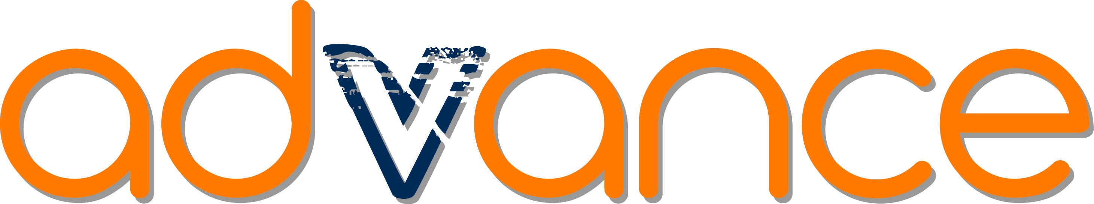

Brauer College
In 2018, participants from the Advance program were able to achieve nationally recognised training in the form of the Certificate II in Public Safety - Aquatic Rescue which also incorporated the bronze medal through the Duke of Ed Awards. This involved knowledge and key practical skills in the areas of CPR, First Aid, Aquatic rescues, communication and OH & S issues within a workplace. Much of the training for this award took place at the local surf club where students were able to utilise the equipment, facilities, knowledge and expertise of club members.
This allowed the group to participate in voluntary patrols over the summer months at their local Surf Lifesaving Club (Warrnambool or Port Fairy) and assisted them to maintain public safety in the beach environment. Students in first semester were involved in a community project with St Johns Dennington Primary School.
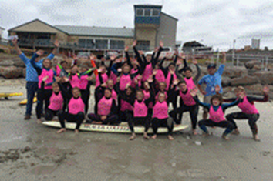
The project aimed to develop surf skills and awareness of youth in the safe use of the local beach by primary aged students in Warrnambool. The beach activities were designed and run by the students in the group. They were required to first learn about the abilities of the students and design appropriate yet challenging activities for the primary students.
The activities were organised to test their beach safety, speed, teamwork and knowledge. A post activity analysis was undertaken with the view to further improve the program for future engagement with local primary aged students. Students in first semester also undertook training in the Senior First Aid award which is equivalent to a Level II first aid training.
The formal training undertaken allowed the students to increase their communication skills within the group and particularly when dealing with members of the public. They studied verbal and non-verbal communication and learnt skills in the use of signals, flags and radios to communicate safety messages to patrol members and the public. This also gave them a wider experience of working as a team within a work environment - a key skill for future years. The addition of the program participants as members to their local surf club made a real difference to the member base and therefore patrol strength at their local clubs. Throughout the program the students relied on each other to work together as a team to be involved in the training sessions and various other activities undertaken such as the interstate camps and primary school programs.
Most decisions for this program were student led in consultation with the staff. Participants were given the task to design one of the camps and present to the remainder of the group. The class voted on the best presented camp and this was the one organised for them to attend. They also were able to have input into the types of activities undertaken and methods/modes of getting around the City during the camp run in Semester 2 to Bondi Beach. The group further organised and designed the program for the primary school groups.
Students are given the opportunity to attend two different camps to different coastal locations to experience new activities and scenery. These camps were designed to not only be fun but also incorporate the development of persistence, initiative, teamwork and independence through a varying range of activities. Students have been acknowledged on numerous occasions at their Year Level and whole school assemblies recognising their efforts and have been awarded certificates for the training undertaken. Students are involved in an end of program celebration which generally involves a luncheon and/or fun activity such as Laser Strike. The local Surf Club’s hold annual dinners which also celebrate the successes over the season.
There were students who had joined the Surf Club due to their involvement in the Advance program who were recognised for their efforts at the Annual dinner.

Greensborough College
The Year 11 and Year 12 Victorian Certificate of Applied Learning (VCAL) students from Greensborough College participated in the Advance program in 2018 by focussing on personal development skills. The Year 11 VCAL class completed community projects in units including Walkability, The Royal Children's Hospital Appeal, The Environment, Us and finally a Gambling unit. The Year 11 students also partnered up with the Diamond Valley Special Development School and created workshop activities that enabled Greensborough College students to work with students with disabilities. They also completed a RSPCA Unit (Sem 2) which related to visiting animal shelters and building skills around caring for animals.
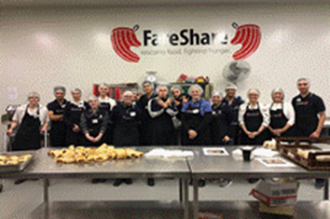
The Year 12 VCAL classes worked on the unit of 'Homelessness' (Sem 1) that focused on the programs offered by the Salvation Army and The Big Issue. In Semester 2, students worked on the unit of 'RACV' which allowed them to understand the possible dangers of driving on today's roads. Students were given strict timelines to complete outcomes while in the classroom.
Students were able to develop their leadership skills, communication skills, maturity and knowledge and understanding of the VCAL programs. Students in VCAL Year 11 completed their Level 2 First Aid, 20 weeks of classroom workshops and 15 weeks of RSPCA Programs. Students in Year 12 were involved in the Fareshare program for the homelessness and worked and received talks with guest speakers from The Big Issue. The Year 12 students were also involved in programs run by RYDA that linked to the RACV car safety outcomes. The Year 12 students were also able to complete their RSA and Barrista Courses/Certificates.
These programs enabled students to understand the impact of decisions made by the youth of today and the consequences that may come with those decisions. For example, understanding the 100,000 Australians that are living on the streets each night or the significant number of deaths on our roads under the age of 25.
While the teacher provides the VCAL program, all units of work were students led. Students are given the task to initiate contact with the variety of VCAL institutions themselves and organise times when they can run set programs. For example, students organised a roster of classmates to ring venues each fortnight to book in events (RYDA), guest speakers (The Big Issue), bus companies etc.
Students also organised their own projects (RSPCA approved Foundations), fundraising activities (Salvation Army) and food drives (Fareshare) to be able to meet all unit requirements. Both Year 11 and 12 students created school-wide events for the Royal Children's Hospital and Cupcake Day for Animal Awareness.
All Year 11 students received their First Aid Certificate after completion of the First Aid Course as recognition. Students were given opportunities to work with the Salvation Army and at Animal shelters as part of volunteer/paid work. Students were rewarded with a VCAL certificate of intermediate and senior levels for successfully completing the required VCAL units.

The Victorian College for the Deaf
The Victorian College for the Deaf used Advance to implement the Hands on Learning (HOL) Program to engage students with their pathways and wellbeing in 2018. The students led various community-based projects by identifying their own focus goals and linking it with their projects within the school. They met at the HOL work centre for their weekly planning of the projects. HOL students attended Victorian Parliament at the end of first Term to showcase their work and received positive acknowledgement of their projects. The HOL students also achieved their major project to support Deaf Children Australia in creating Halloween themed props for the special Halloween event at the Bluestone.
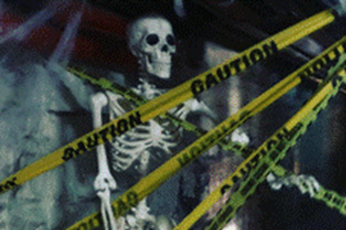
The Bike Program through Advance has facilitated bicycle education for the Year 9 & 10 students. Students have been involved in undertaking tasks to plan for and develop a bike education program, repurposing of an allocated space for VET delivery of Bicycle Mechanical Technology and connecting with organisations in the communities. The Bike Program group took a trip out to Coburg High School on a fact-finding mission on how to build a large bike shelter and bike maintenance shed.
Students investigated the inner workings of the bike program and took part in analysing aspects of it. The bike program co-ordinator has undertaken personal development and training to further the potential and scope of the project. Students have worked with the co-ordinator to set up the space for the implementation of a program that provides them an opportunity to participate and work in a hands-on environment as well as interact with the public. This has provided students with ownership of the project in the beginning stages of what is a longer-term project with further stages to be implemented in coming years.
Year 11 & 12 students were provided interpreter support to access and complete their Certificate II in VET Hospitality & Kitchen Operations (dual program) via The Inner Melbourne VET Cluster.
Travel Education program for Middle and Senior Years students, Year 7 to 12, was student led. Students participated in the travel education program on a weekly basis to identify the needs of students working towards independent travel and road safety. Students planned and led the class to visit destinations within Melbourne city and surrounds as well as their home suburbs. After the completion of their travel, students reported back through their class digital portfolios to explain their journey plans.
The Advance program initiatives and programs enhanced the students' leadership, team work, employability skills and wellbeing. They have participated in Deaf community events with the involvement of strong role models. All programs were led by Year 7 to 12 students with support from teaching staff and interpreters. This was also part of the senior student’s VCAL learning outcomes where they were expected to discuss, plan and lead projects.
HOL students presented their project to Ministers from Victorian Parliament during the first term and were commended by MPs for their successful billy cart project. HOL students received awards for their contribution to the school community and VCAL students were acknowledged and praised by the leadership team at the school assembly.

Surf Coast Secondary College
For the Advance program in 2018, students at Surf Coast Secondary College participated in a range of community projects throughout the year. These programs included the community food caravan project by the VCLA students, completion of a barista course, involvement in the Scope Young Ambassadors program, Planet Ark National Tree Day, student voice sustainability project, a school production and the Great Victorian Bike Ride.
To highlight one of the community projects under Advance, the VCAL Community Food Caravan Project was an initiation of the Year 11 and 12 students. The students put forward a funding application to the Advance Coordinator and were able to articulate how the project met the Advance outcomes. The project was ongoing and involved the donation of a caravan by a community member. It involved partnerships between students and community organisations such as the Salvation Army and Rotary International. The students have also developed a partnership with a local business, Achtung Campers, who are donating workshop space and tools.
The learning outcomes and key skills students obtained through their participation in the program include knowing individual strengths and weaknesses, developing strategies for growth, the ability to develop connections between young people and the community and their potential to contribute.
Students also developed effective communication skills to ensure an inclusive community for all. The ability to work in teams to overcome challenges and develop an awareness of the contribution of individuals and roles of others in team was a further skill development. Students were also able to research, identify and plan possible community projects and volunteering opportunities along with monitor, evaluate and reflect on the learning gained from the projects and the overall contribution made to the community.
Students were involved in the decision-making process in several ways. Young people-initiated projects such as sustainable fresh produce bags and Planet Ark National Tree Day. The VCAL Community Food Van project was discussed and debated with students and teachers. Students then completed a funding application and were able to clearly articulate their decision-making process. Projects such as the Scope Young Ambassadors program was a shared decision with staff. The program was initiated by the coordinator, but students had the opportunity to provide feedback and were engaged in the process. In future years, the implementation of the program will be considered, with opportunity for youth consultation and leadership in follow up community inclusion projects.
Celebration for student achievements included recognition in local media. This involved newsletter articles and articles in local news publications. For recognised training and learning modules, students received certificates. Another key component of the program was funding allocation to student wellbeing and celebration days. These events included guest speakers and catering to celebrate the success of different year levels.
